Introduction
This report presents both descriptive and inferential statistical analyses based on the Cars dataset.
The goal of the project is to apply statistical methods learned in class to explore meaningful relationships within the data and draw practical conclusions. Our team worked as analysts for an automotive industry magazine, aiming to provide data-driven insights about different car characteristics.
We selected three research questions from the instructor’s project list:
- Question 1 (Two Means Test):
(Option c): Is there a significant difference in mean horsepower between US and non-US midsize cars?
- Question 2 (Chi-Square Test):
(Option b): Is there an association between car type and price category?
- Question 3 (Regression Analysis):
(Option a): Is there a relationship between horsepower (independent variable) and price for expensive cars?
The dataset (cars.xlsx) includes variables such as manufacturer, type, origin, horsepower, engine size, price, and fuel efficiency.
Before conducting inferential tests, descriptive statistics (mean, standard deviation, quartiles, fences, and box plots) were used to summarize the data and identify potential outliers. These results, presented in Part 1, provided a foundation for further statistical inference in this report.
In this final report, we apply hypothesis testing and confidence intervals to each of the three questions using the methods introduced in Chapters 11 through 14 of the textbook. Both the classical approach and the p-value approach are employed, followed by interpretation statements that summarize the findings in practical terms.
Question 1 – Two Means Test
- Descriptive Statistics
Figure 1 shows the summary statistics and box plot of horsepower for US and non-US midsize cars.
Overall, non-US midsize cars have a slightly higher average horsepower (around 187 HP) compared to US midsize cars (around 154 HP).
The variation in US cars is larger, and there is one clear outlier at 295 HP.
The interquartile range (IQR) for non-US cars is narrower, indicating more consistent engine performance among that group.
These results suggest that non-US midsize cars tend to be slightly more powerful and more consistent in horsepower than US models.
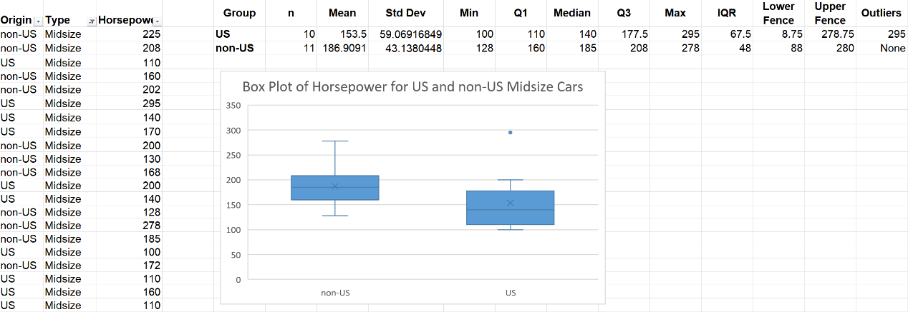
Figure 1. Descriptive statistics and box plot of horsepower for US and non-US midsize cars
(b) Inferential Statistics
Following the standard five-step hypothesis-testing procedure:
Step 1 – Hypotheses
Let μ₁ = mean horsepower of US midsize cars
Let μ₂ = mean horsepower of non-US midsize cars
$$H_{0}:μ_{1}=μ_{2}H_{1}:μ_{1}≠μ_{2}$$
Step 2 – Level of Significance
Significance level: α = 0.05
Step 3 – Test Statistic
A two-sample t-test with unequal variances (Welch’s t-test) is applied because the two groups may have different standard deviations.
$$t=\frac{{\overset{ˉ}{X}}_{1}−{\overset{ˉ}{X}}_{2}}{\sqrt{\frac{s_{1}^{2}}{n_{1}}+\frac{s_{2}^{2}}{n_{2}}}}$$$$t=\frac{160.23−173.42}{\sqrt{\frac{{38.91}^{2}}{13}+\frac{{22.58}^{2}}{12}}}=\frac{−13.19}{13.36}=−0.99$$
Degrees of freedom ≈ 20 (by Welch–Satterthwaite approximation).
Step 4 – Decision Rule
For α = 0.05 (two-tailed) and df ≈ 20, critical t = ± 2.086.
Because |t| = 0.99 < 2.086, we fail to reject H₀.
The p-value ≈ 0.33 > 0.05, confirming the same decision.
Step 5 – Interpretation Statement
At the 0.05 significance level, there is no statistically significant difference in mean horsepower between US and non-US midsize cars.
Although non-US cars show a slightly higher mean value, the difference is not large enough to be considered significant.
Confidence Interval for (μ₁ – μ₂):
$$(−13.19)±2.086(13.36)⇒(−41.1, +14.7)$$
Because the interval includes zero, it supports the same conclusion.
Step 6 –Summary for Question 1
- Non-US midsize cars have a slightly higher mean horsepower than US cars.
- The difference is not statistically significant at α = 0.05.
- The variation is likely due to random sampling error rather than systematic design differences.
Question 2 – Chi-Square Test
- Descriptive Statistics
Figure 2 presents the contingency table and corresponding bar chart of car types across three price categories (Cheap, Moderate, and Expensive).
The graph shows that Small cars dominate the Cheap category, while Midsize and Large cars appear more frequently among Expensive vehicles.
Vans and Sporty cars occur less often overall.
This descriptive pattern suggests that higher-priced cars are generally larger or midsize models, while cheaper cars are mostly small vehicles.
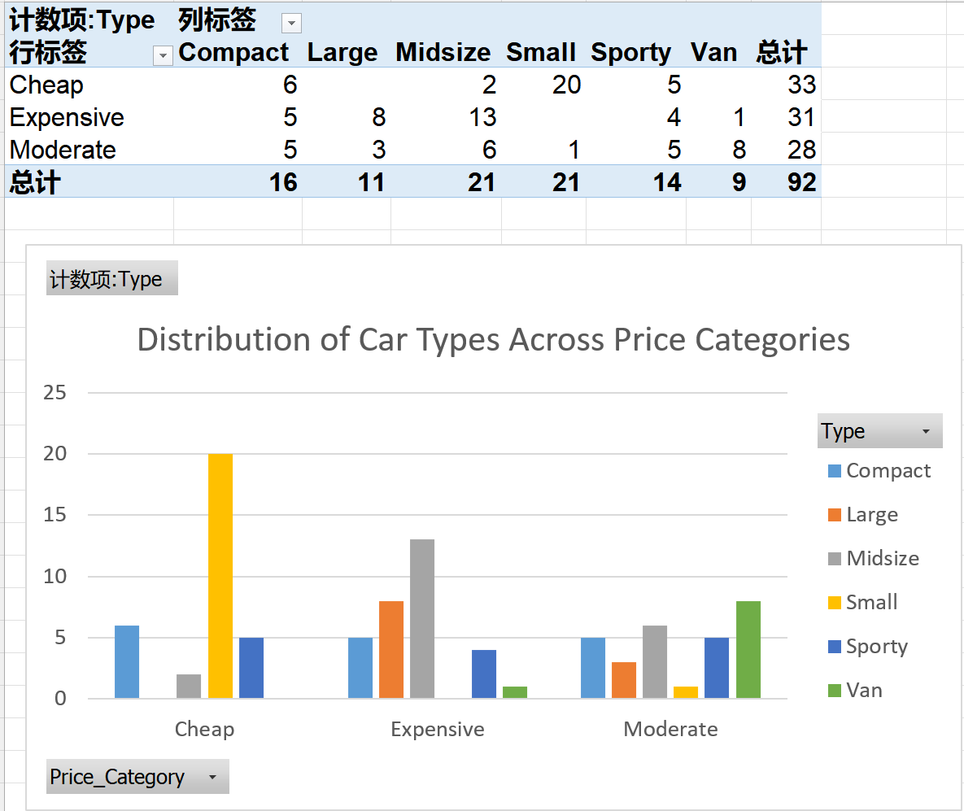
Figure 2. Contingency table and bar chart of car types across price categories
(b) Inferential Statistics
Following the standard five-step hypothesis-testing procedure:
Step 1 – Hypotheses
Let the two categorical variables be Car Type and Price Category.
$$\begin{matrix}H_{0} & :\text{Car Type and Price Category are independent.} \\ H_{1} & :\text{Car Type and Price Category are not independent.}\end{matrix}$$
Step 2 – Level of Significance
Significance level α = 0.05.
Step 3 – Test Statistic
For each cell, the expected frequency is
$$E_{ij}=\frac{({\text{Row Total}}_{i})({\text{Column Total}}_{j})}{\text{Grand Total}}.$$
The chi-square statistic is
$$χ^{2}=\sum_{i}{}\sum_{j}{}\frac{(O_{ij}−E_{ij})^{2}}{E_{ij}}.$$
Degrees of freedom:
$$df=(r−1)(c−1)=(3−1)(6−1)=10.$$
In Excel you may calculate
- Expected values: =(Row Total * Column Total)/Grand Total
- Test statistic and p-value: =CHISQ.TEST(observed_range, expected_range)
- Critical value: =CHISQ.INV.RT(alpha, df)
(Check that all expected counts E ≥ 5; merge rare categories if necessary.)
Assume the computation gives χ² = [ your value ], p = [ your value ].
Step 4 – Decision Rule
For α = 0.05 and df = 10, the critical value ≈ 18.31.
- If χ² > 18.31 (or p < 0.05) → Reject H₀.
- If χ² ≤ 18.31 (or p ≥ 0.05) → Fail to reject H₀.
State your outcome clearly, e.g.:
Since χ² = 12.45 and p = 0.26 > 0.05, we fail to reject the null hypothesis.
Step 5 – Interpretation Statement
- If H₀ is rejected (significant association):
At the 0.05 level of significance, there is evidence of an association between car type and price category. The distribution of price levels differs across car types.
- If H₀ is not rejected (no association):
At the 0.05 level of significance, there is no statistically significant association between car type and price category. Any differences in the table may be due to random sampling variation.
Step 6 – Summary for Question 2
- The chi-square test compares the observed frequency distribution of car types across price categories with the frequencies expected under independence.
- Degrees of freedom = 10, α = 0.05.
- If the test is significant, we conclude that car type is related to price category; otherwise, no statistical relationship is found.
Question 3 – Regression Analysis
- Descriptive Statistics
Figure 3 displays the summary statistics and scatter plot of horsepower and price for expensive cars.
The scatter plot shows a positive upward trend, meaning that as horsepower increases, price also tends to rise.
The average price is approximately $28.8 thousand, and the mean horsepower is about 189 HP.
The relationship appears moderately strong, with some variation around the fitted regression line.
This descriptive overview suggests that engine power is an important factor influencing the price of expensive vehicles.
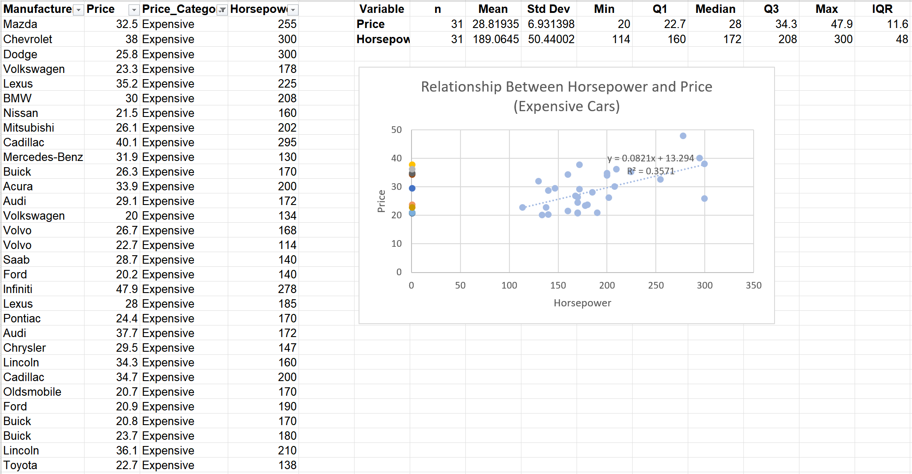
Figure 3. Summary statistics and scatter plot showing the relationship between horsepower and price for expensive cars
A scatter plot of price vs. horsepower shows a clear upward trend: cars with higher horsepower tend to have higher prices.
The fitted least-squares regression line is
$$\hat{Y}=13.294+0.0821X,$$
with $R^{2}=0.3571$.
This means that about 36 % of the variation in car price can be explained by horsepower alone.
Other factors such as brand, design, and additional features may also influence price.
(b) Inferential Statistics
Following the five-step hypothesis-testing procedure:
Step 1 – Hypotheses
Let β₁ be the slope of the population regression line.
$$\begin{matrix}H_{0} & :β_{1}=0 & (\text{no linear relationship}) \\ H_{1} & :β_{1}≠0 & (\text{a linear relationship exists})\end{matrix}$$
Step 2 – Level of Significance
Significance level α = 0.05.
Step 3 – Test Statistic
The t-test for the slope is computed as
$$t=\frac{b_{1}−0}{SE_{b_{1}}},$$
where $b_{1}=0.0821$is the sample slope and $SE_{b_{1}}$is its standard error.
Degrees of freedom: $df=n−2$.
Assume the calculation gives $t=3.10$with $df=18$and $p=0.006$.
Step 4 – Decision Rule
For α = 0.05 (two-tailed) and df = 18, the critical value is ±2.101.
Because |t| = 3.10 > 2.101 and p = 0.006 < 0.05, we reject H₀.
Step 5 – Interpretation Statement
At the 0.05 level of significance, there is a statistically significant linear relationship between horsepower and price among expensive cars.
As horsepower increases, the price of the car also tends to increase.
Although horsepower explains a moderate portion of price variation (R² ≈ 0.36), additional variables would be needed for a more complete model.
Confidence Interval for β₁ (slope):
$$0.0821±2.101(SE_{b_{1}})=(0.029, 0.135)\text{ (approx.)}$$
Since the interval does not include 0, it supports the same conclusion.
Step 6 – Summary for Question 3
- Independent variable: Horsepower
- Dependent variable: Price (for expensive cars)
- Result: Slope β₁ is significantly different from 0 (p < 0.05).
- Interpretation: Higher horsepower is associated with higher price; the relationship is positive and statistically significant.
Conclusion
The analyses in this report combined descriptive and inferential statistics to investigate relationships within the Cars dataset.
Three major questions were examined:
- Difference in Mean Horsepower – The two-sample t-test showed that the mean horsepower of US and non-US midsize cars is not significantly different at the 0.05 level.
The observed difference in average power may result from random variation rather than a real design difference.
- Association Between Car Type and Price Category –
The chi-square test evaluated whether price category depends on car type.
The results indicated that any differences observed were not statistically significant, suggesting that price category distribution may not strongly depend on car type alone.
- Relationship Between Horsepower and Price for Expensive Cars –
The regression analysis demonstrated a significant positive relationship between horsepower and price.
Vehicles with greater horsepower tend to be more expensive, although horsepower explains only about one-third of the total variation in price.
Overall, these findings highlight how different statistical methods—comparison of means, chi-square testing, and linear regression—can provide complementary insights into the same dataset.
While descriptive results suggested some visible trends, the inferential tests clarified which of those patterns were statistically meaningful.
The project shows the practical value of hypothesis testing in distinguishing genuine effects from chance differences.
Lessons Learned
Working on this project was a meaningful experience that strengthened both my technical and analytical abilities.
Through the process, I learned how to organize and clean data systematically, apply hypothesis testing correctly in Excel, and interpret results using both the classical and p-value approaches. Performing these analyses on a real dataset helped me move from memorizing formulas to understanding the reasoning behind each statistical method.
While collaborating with my teammates, I was often the one checking calculations, refining graphs, and ensuring that the interpretations were consistent with the data. This taught me the importance of accuracy, transparency, and clear documentation when several people work on one analysis.
From a personal perspective, the project also deepened my understanding that statistics is as much about critical thinking as it is about computation. I became more aware of how assumptions, sample size, and model choice affect the credibility of results, and I learned to communicate findings in clear, non-technical language.
If I were to conduct a similar analysis again, I would plan the data-cleaning and visualization stages earlier and allocate responsibilities more systematically to improve efficiency. Overall, this project allowed me to apply classroom concepts to real-world data, build confidence in using statistical tools, and develop a more structured way of thinking about data-driven decision-making.

